# Lab: Advanced Functions

Problems for in-class lab for the ["JavaScript Advanced" course @ SoftUni](https://softuni.bg/trainings/3588/js-advanced-january-2022). Submit your solutions in the SoftUni judge system at https://judge.softuni.bg/Contests/2764/Advanced-Functions-Lab.

## Area and Volume Calculator

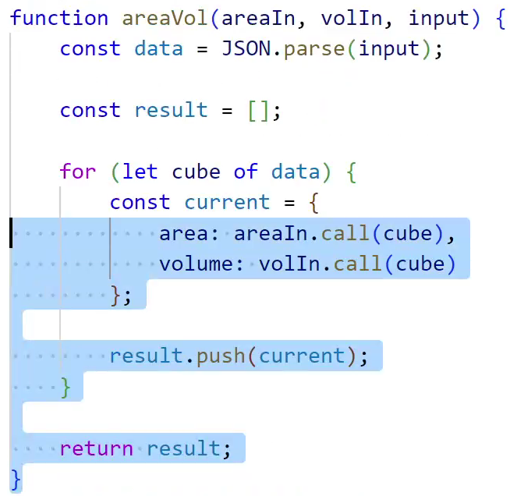

Write a function that **calculates** the **area** and the **volume** of a figure, which is **defined** by its **coordinates**   
(**x**, **y**, **z**).

|  |
| --- |
| area() |
| function area() {      return Math.abs(this.x * this.y);  }; |

|  |
| --- |
| vol() |
| function vol() {      return Math.abs(this.x * this.y * this.z);  }; |

|  |
| --- |
| solve() |
| function solve(area, vol, input) {      //ToDo....  } |

### Input

You will receive **3** parameters - the **functions** **area** and **vol** and a **string**, which contains the figures' coordinates.

**For more information check the examples.**

### Output

The output should be **returned** as an **array** **of objects**. Each object has **two** **properties**: the figure's **area** and **volume**.

**[**

**{ area: ${area1}, volume: ${volume1} },**

**{ area: ${area2}, volume: ${volume2} },**

**. . .**

**]**

### Note:

**Submit only the solve function.**

### Examples

|  |  |
| --- | --- |
| Sample Input | Output |
| area, vol, `[  {"x":"1","y":"2","z":"10"},  {"x":"7","y":"7","z":"10"},  {"x":"5","y":"2","z":"10"}  ]` | [  { area: 2, volume: 20 },  { area: 49, volume: 490 },  { area: 10, volume: 100 }  ] |
| area, vol, `[  {"x":"10","y":"-22","z":"10"},  {"x":"47","y":"7","z":"-5"},  {"x":"55","y":"8","z":"0"},  {"x":"100","y":"100","z":"100"},  {"x":"55","y":"80","z":"250"}  ]` | [  { area: 220, volume: 2200 },  { area: 329, volume: 1645 },  { area: 440, volume: 0 },  { area: 10000, volume: 1000000 },  { area: 4400, volume: 1100000 }  ] |

## Add

Write a program that keeps a number **inside its context** and **returns** a new function that **adds** a **given** number to the previous one.

### Input

Check the **examples** **below** to see how your code will be executed.

### Output

Your function should **return** the final result.

### Examples

|  |  |
| --- | --- |
| Sample Input | Output |
| let add5 = solution(5);  console.log(add5(2));  console.log(add5(3)); | 7  8 |
| let add7 = solution(7);  console.log(add7(2));  console.log(add7(3)); | 9  10 |

## Currency Format

Write a **higher-order** function createFormatter that fixes some of the parameters of another function. Your program will **receive four parameters**: **three values** and a **function** that **takes 4 parameters** and **returns a formatted string** (a monetary value with currency symbol).

Your task is to **return a partially applied function**, based on the input function that has its **first three** parameters fixed and only **takes one parameter**.

You will receive the following function:

|  |
| --- |
| currencyFormatter |
| function currencyFormatter(separator, symbol, symbolFirst, value) {  let result = Math.trunc(value) + separator;  result += value.toFixed(2).substr(-2,2);  if (symbolFirst) return symbol + ' ' + result;  else return result + ' ' + symbol;  } |

Receive and set the following parameters to fixed values:

separator

symbol

symbolFirst

The final parameter value is the one that the returned function must receive.

### Input

You will receive four parameters:

* separator (string)
* symbol (string)
* symbolFirst (Boolean)
* formatter (function)

### Output

You need to **return a function** that takes one parameter - value

### Examples

|  |
| --- |
| Sample Input |
| let dollarFormatter = createFormatter(',', '$', true, currencyFormatter);  console.log(dollarFormatter(5345)); *// $ 5345,00*  console.log(dollarFormatter(3.1429)); *// $ 3,14*  console.log(dollarFormatter(2.709)); *// $ 2,71* |

## Filter Employees

Write a program that filters the employees of your company. You should print the result in a specific format. You will receive **2** parameters (**data**, **criteria**). You should **parse** the input, find all employees that fulfill the criteria, and print them.

### Input

You will receive a **string** with all the employees, and **criteria** by which you should sort the employees. If the criteria are **"all"** print all the employees in the given format.

### Output

The output should be **printed** on the console.

For more information check the examples.

### Examples

|  |  |
| --- | --- |
| Sample Input | Output |
| `[{  "id": "1",  "first_name": "Ardine",  "last_name": "Bassam",  "email": "abassam0@cnn.com",  "gender": "Female"  }, {  "id": "2",  "first_name": "Kizzee",  "last_name": "Jost",  "email": "kjost1@forbes.com",  "gender": "Female"  },  {  "id": "3",  "first_name": "Evanne",  "last_name": "Maldin",  "email": "emaldin2@hostgator.com",  "gender": "Male"  }]`,  'gender-Female' | 0. Ardine Bassam - abassam0@cnn.com  1. Kizzee Jost - kjost1@forbes.com |
| `[{  "id": "1",  "first_name": "Kaylee",  "last_name": "Johnson",  "email": "k0@cnn.com",  "gender": "Female"  }, {  "id": "2",  "first_name": "Kizzee",  "last_name": "Johnson",  "email": "kjost1@forbes.com",  "gender": "Female"  }, {  "id": "3",  "first_name": "Evanne",  "last_name": "Maldin",  "email": "emaldin2@hostgator.com",  "gender": "Male"  }, {  "id": "4",  "first_name": "Evanne",  "last_name": "Johnson",  "email": "ev2@hostgator.com",  "gender": "Male"  }]`,  'last_name-Johnson' | 0. Kaylee Johnson - k0@cnn.com  1. Kizzee Johnson - kjost1@forbes.com  2. Evanne Johnson - ev2@hostgator.com |

## Command Processor

Write a program that keeps a string **inside its context** and can execute different **commands** that modify or print the string on the console.

append(string) - append the given **string** at the end of the internal string

removeStart(n) - **remove** the **first** **n** characters from the string, n is an integer

removeEnd(n) - **remove** the **last n** characters from the string, n is an integer

print - **print** the stored string on the **console**

### Input

Check the examples below to see how your code will be executed.

### Output

Whenever you receive the command print, the output should be **printed** on the console.

### Examples

|  |  |
| --- | --- |
| Sample Input | Output |
| let firstZeroTest = solution();  firstZeroTest.append('hello');  firstZeroTest.append('again');  firstZeroTest.removeStart(3);  firstZeroTest.removeEnd(4);  firstZeroTest.print(); | loa |
| let secondZeroTest = solution();  secondZeroTest.append('123');  secondZeroTest.append('45');  secondZeroTest.removeStart(2);  secondZeroTest.removeEnd(1);  secondZeroTest.print(); | 34 |

## List Processor

Using a closure, create an inner object to process list commands. The commands supported should be the following:

* **add** **<string>** - adds the following string in an inner collection.
* **remove** **<string>** - removes all occurrences of the supplied **<string>** from the inner collection.
* **print** - prints all elements of the inner collection joined by **","**.

### Input

The **input** will come as an **array of strings** - each string represents a **command** to be executed from the command execution engine.

### Output

For every print command - you should print on the console the inner collection joined by **","**.

### Examples

|  |  |
| --- | --- |
| Input | Output |
| [**'add hello'**, **'add again'**, **'remove hello'**, **'add again'**, **'print'**] | **again,again** |
| [**'add pesho'**, **'add george'**, **'add peter'**, **'remove peter'**,**'print'**] | pesho,george |

## Cars

Write a closure that can create and modify objects. All created objects should be **kept** and be accessible by **name**. You should support the following functionality:

* create <name> - creates an object with the supplied **<name>**
* create <name> inherits <parentName> - creates an object with the given <name>, that inherits from the parent object with the <parentName>
* set <name> <key> <value> - sets the property with key equal to <key> to <value> in the object with the supplied <name>.
* print <name> - prints the object with the supplied <name> in the format "<key1>:<value1>,<key2>:<value2>…" - the printing should also print all **inherited properties** from parent objects. Inherited properties should come after own properties.

### Input

The **input** will come as an **array of strings** - each string represents a **command** to be executed from your closure.

### Output

For every print command - you should print on the console all properties of the object in the above-mentioned format.

### Constraints

* **All commands will always be valid, there will be no nonexistent or incorrect input.**

### Examples

|  |  |
| --- | --- |
| Input | Output |
| [**'create c1'**,  **'create c2 inherit c1'**,  **'set c1 color red'**,  **'set c2 model new'**,  **'print c1'**,  **'print c2'**] | **color:red**  **model:new,color:red** |